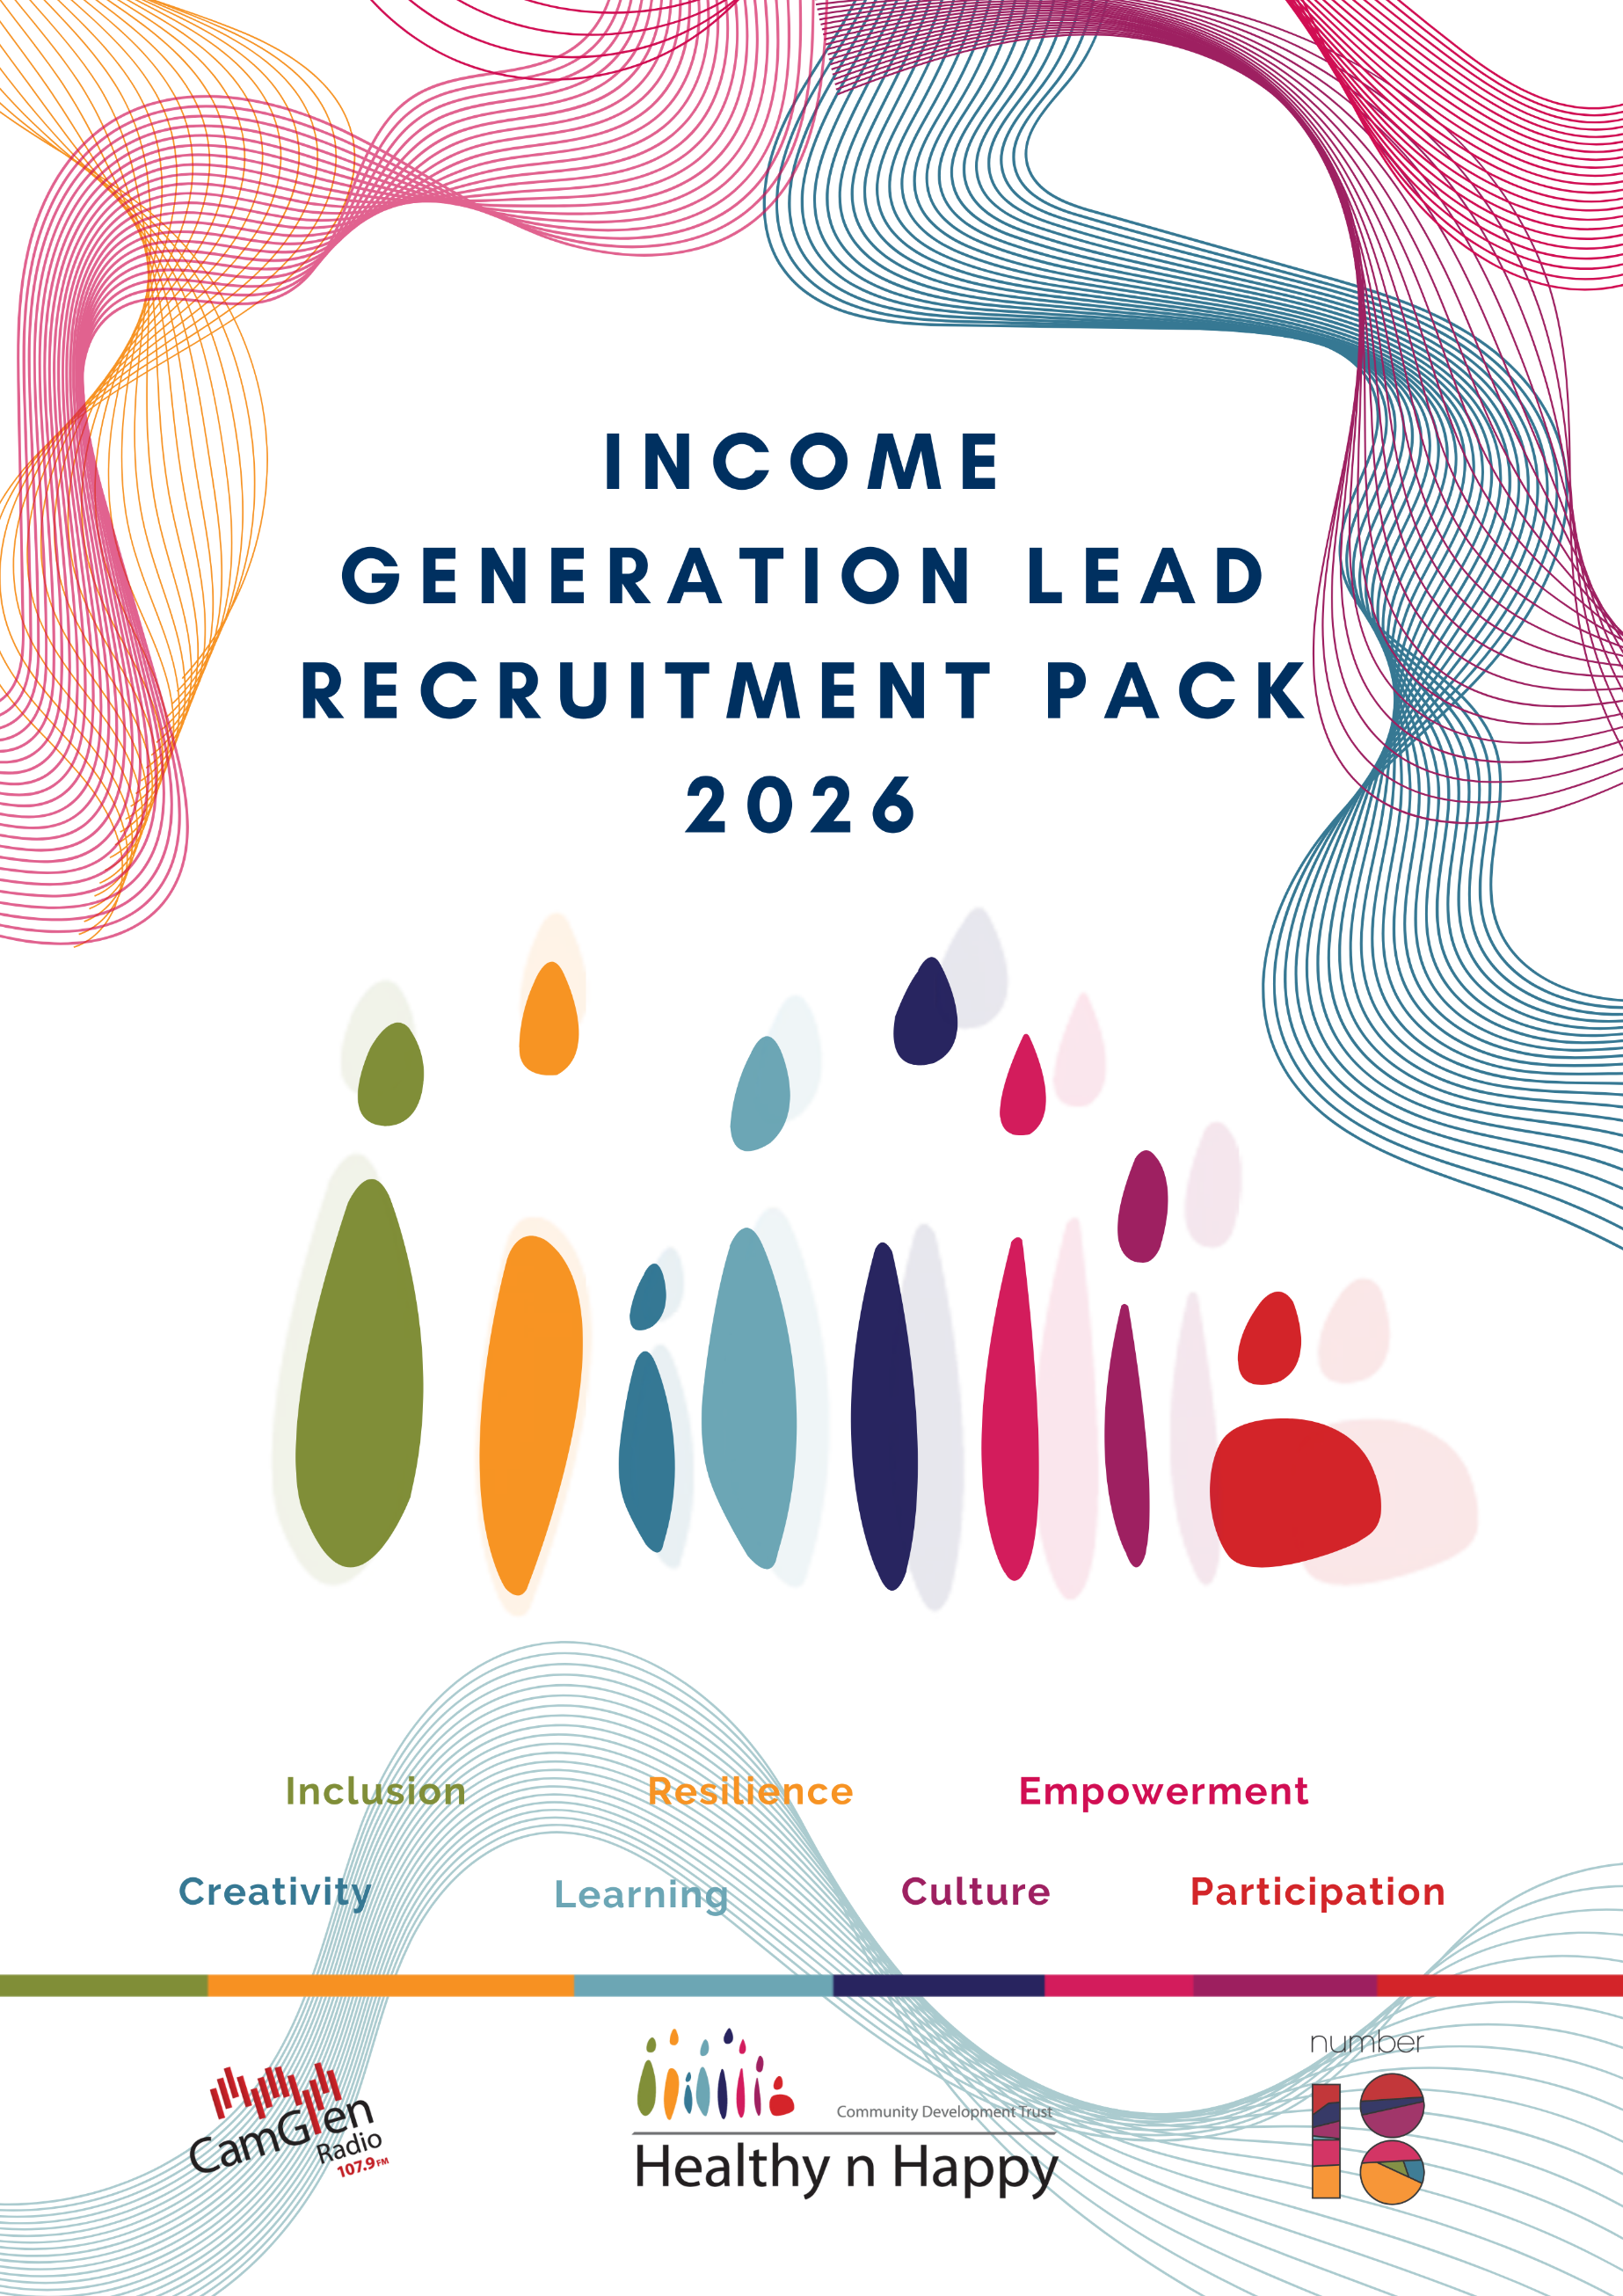

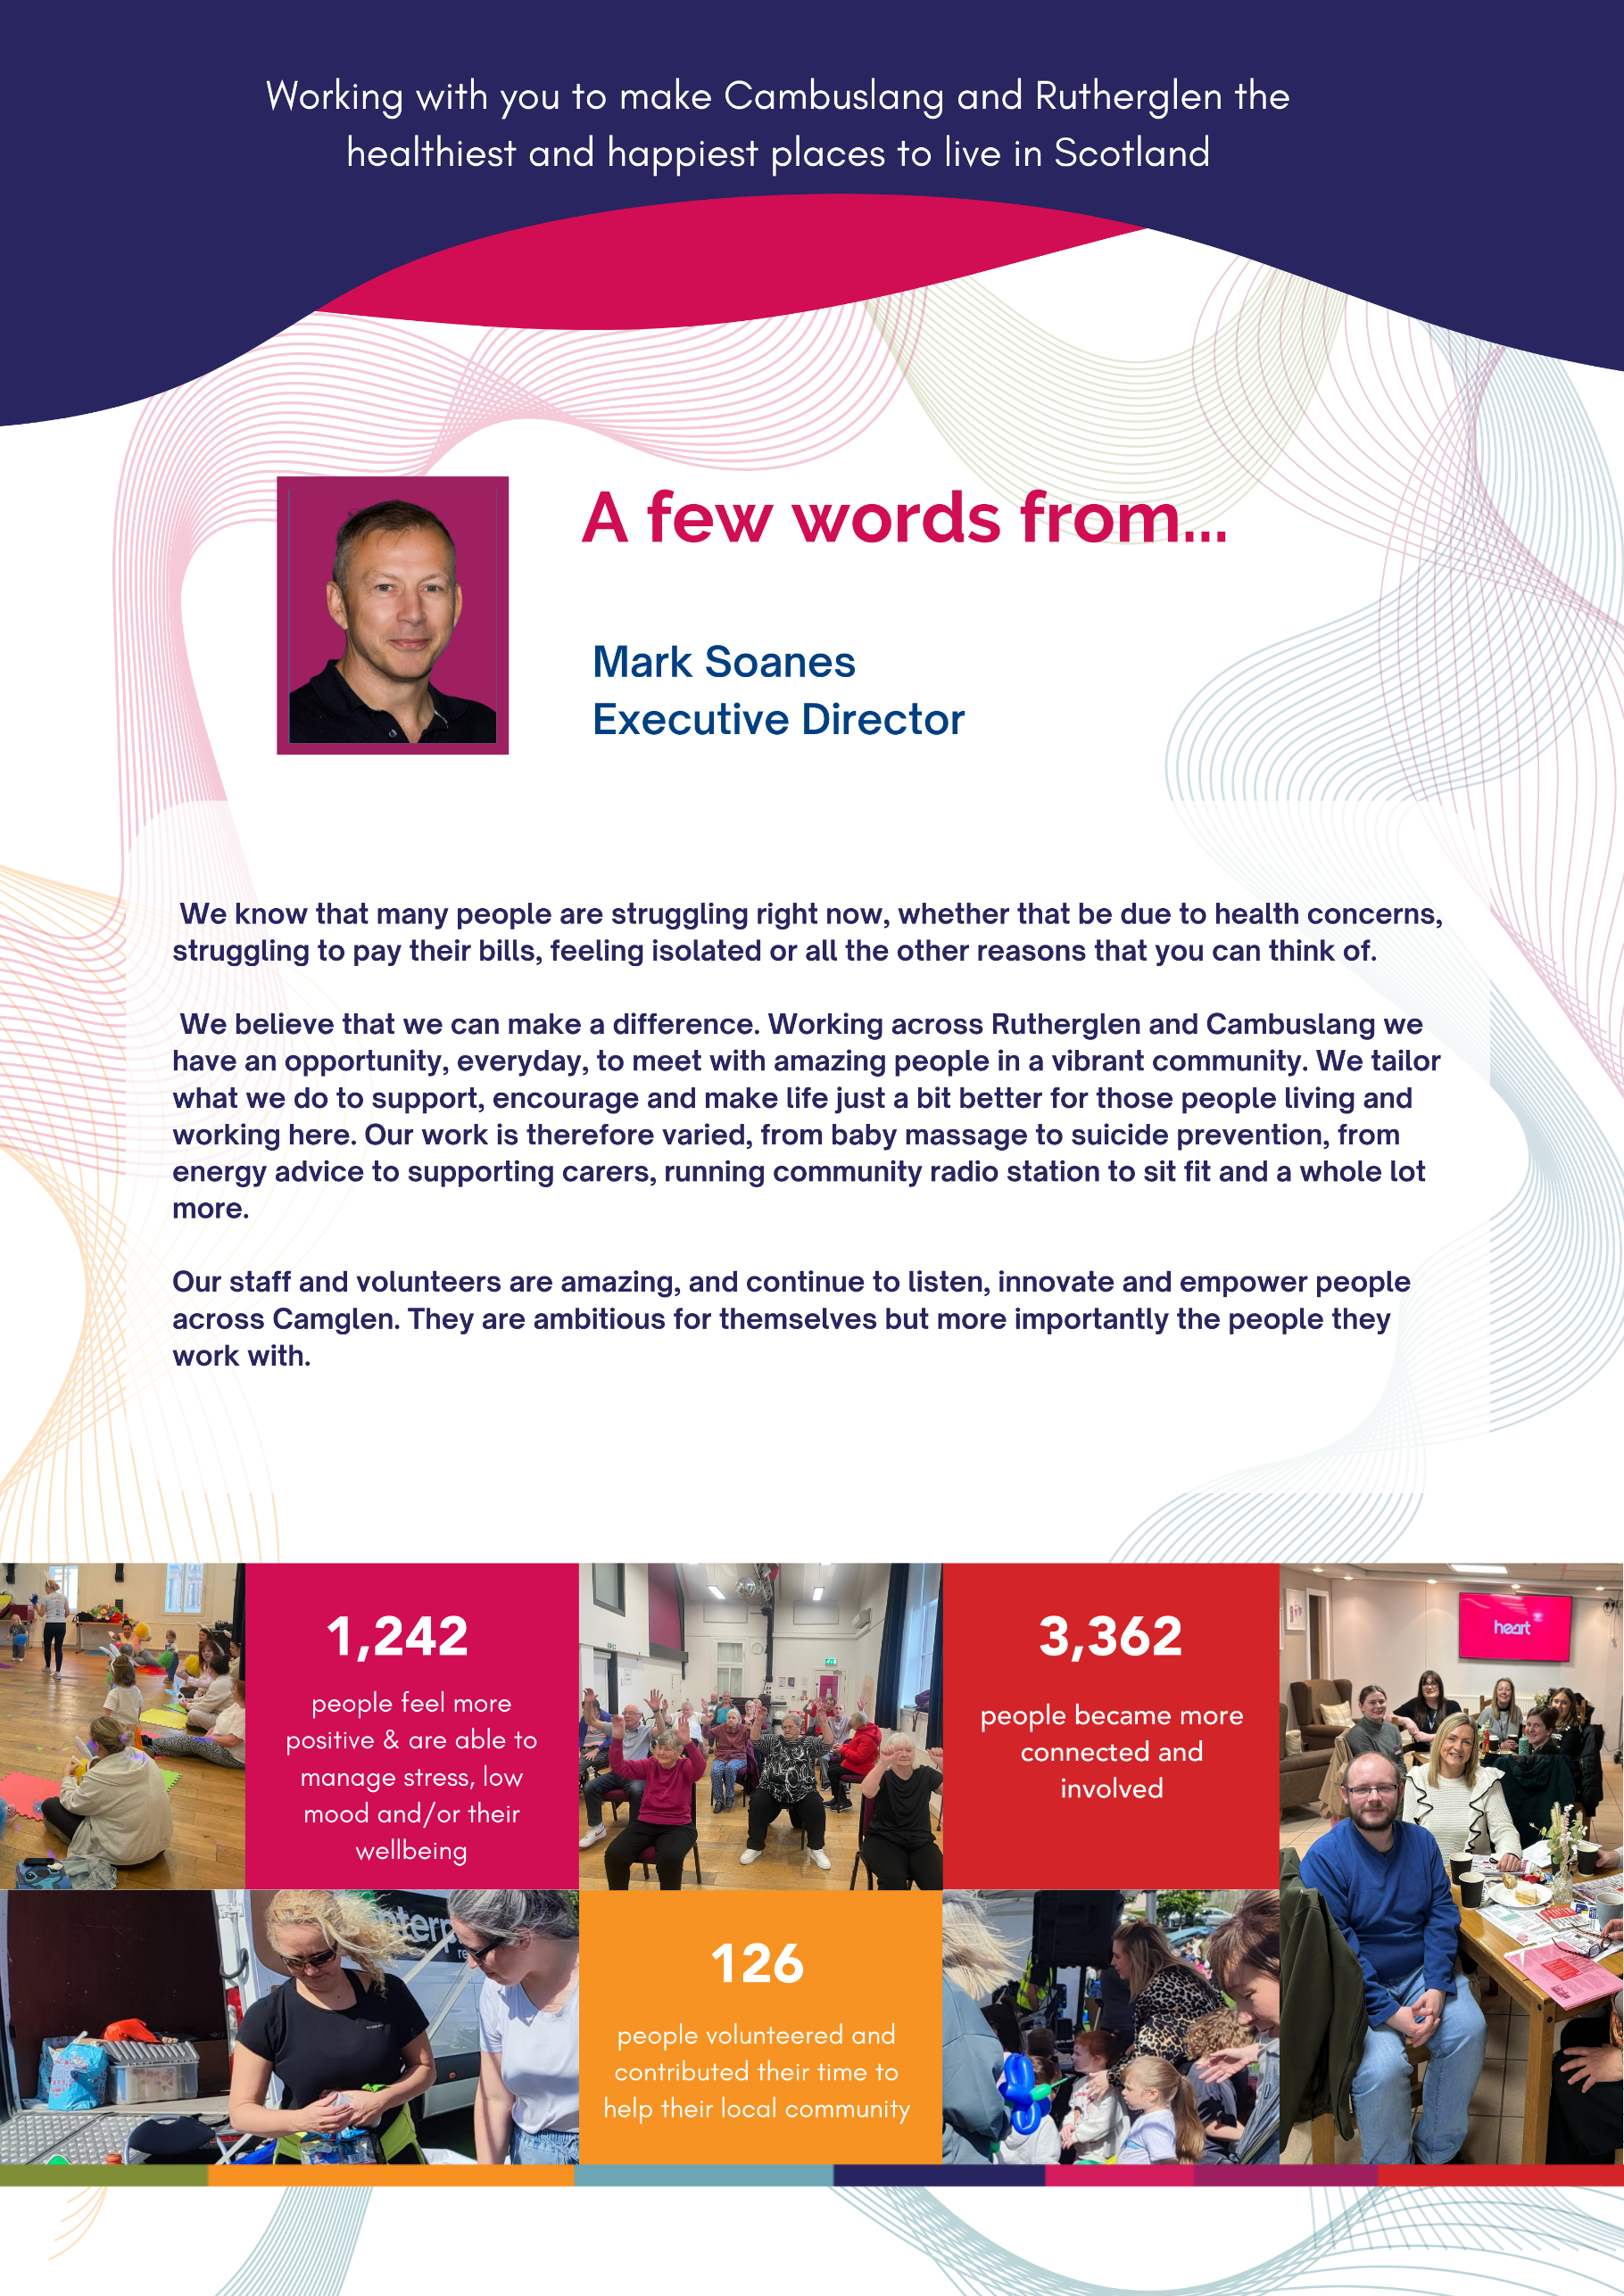

Who we are
We are Healthy n Happy Community Development Trust, an award-winning charity and community owned organisation governed by local people, where all of our work is directed by local priorities.
All of what we offer supports and enables people to make positive changes in their lives and their community. From building confidence and self-esteem, to boosting skills and relationships, to getting more involved in their local neighbourhood and becoming more responsible for their own health and wellbeing.
Our key purpose is to tackle disadvantage and improve lives and communities so they are thriving, resilient and healthy.

What we do
We aim to work with local residents, groups and organisations to make Cambuslang and Rutherglen the healthiest and happiest places to live in Scotland.
Since 2015, we have helped local residents, groups and organisations lever over £2,800,000 direct investment to their local community.

Working in a Shared Leadership Model
Our shared leadership model represents our organisational beliefs, values and attitudes and is an active demonstration of our culture. Shared leadership is a collaborative process of mutual influence, collective sharing, shared delivery of duties and responsibilities and mutual support.
We believe that everyone should be encouraged to develop a leadership role within and across our organisation depending on context and task.
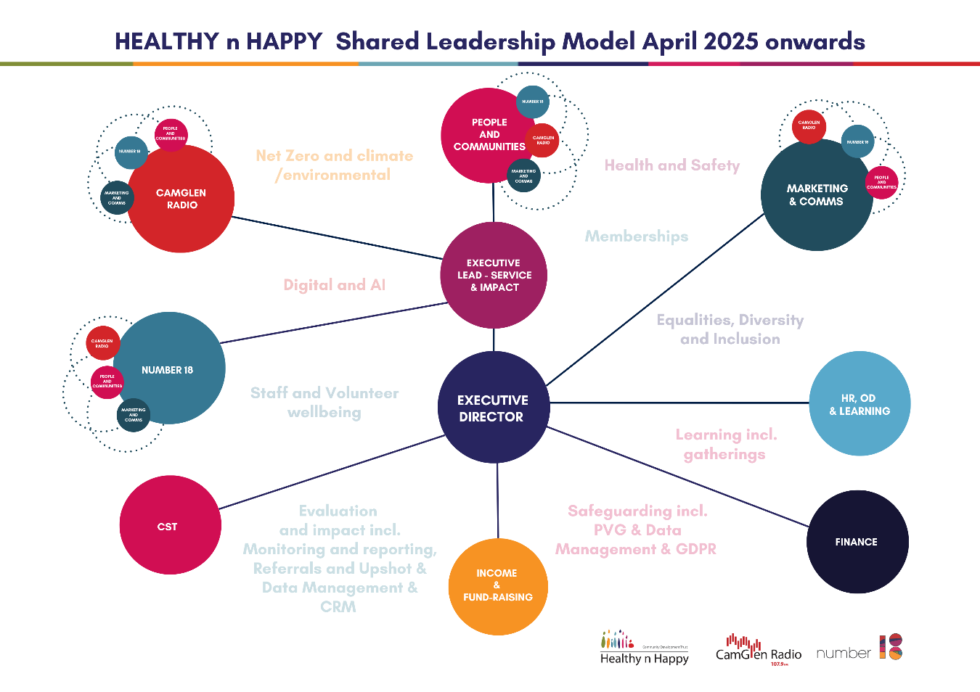
How we organise our people & services

The Role of Income Generation Lead

The Income Generation Lead plays a pivotal role within Healthy n Happy (HnH), leading the development, growth and sustainability of the organisation’s income streams and enterprise activities. This role is central to increasing revenue, strengthening partnerships and ensuring that all income-generating activity aligns with HnH’s social purpose and long-term strategic ambitions.

The Income Generation Lead will work closely with the Healthy n Happy Enterprise Board, the Senior Leadership Team and wider staff teams to drive forward income generation opportunities and maximise financial sustainability. Reporting to senior leadership, the post holder will take a lead role in identifying, developing and delivering innovative approaches to generating income across multiple streams.

The Income Generation Lead will be responsible for developing and implementing a comprehensive Income Generation Strategy, ensuring that all activity supports HnH’s values, enhances its profile and delivers measurable impact across Cambuslang, Rutherglen and beyond.

The role requires a proactive and creative thinker who can build and maintain strong relationships across multiple sectors, including private, public and voluntary organisations. The Income Generation Lead will represent HnH externally, promoting its services, developing partnerships and identifying opportunities for collaboration, sponsorship and growth. The role will also be key in writing and developing existing and new funding opportunities through grant writing and development.

The Income Generation Lead will lead on the development and expansion of key income streams, including enterprise activity, partnerships, sponsorship, venue hire, funding and membership models. This includes exploring new opportunities, piloting innovative initiatives and maximising commercial potential across existing services.

Working collaboratively across all teams, including marketing, fundraising and CamGlen Radio, the Income Generation Lead will ensure a coordinated and organisation-wide approach to income generation. The role will also involve supporting fundraising activity, developing relationships with key supporters and contributing to overall financial resilience.

Key Responsibilities of the Income Generation Lead
Ensure income is generated effectively and sustainably through a range of enterprise activities, partnerships, funding and commercial opportunities.

Support the development of corporate partnerships, sponsorship opportunities and relationships across relevant sectors.

Write and develop funding and grant applications, this will include developing new opportunities and maintaining existing partnerships.

Work with teams to source and develop new funding through grants, trusts and foundations.

Build and maintain positive working relationships with private, public and voluntary sector organisations, businesses and partners.

Represent the organisation at relevant forums, networks and partnerships to promote services and maximise income opportunities.

Provide updates to the Board on income generation and enterprise activity as required.
Undertake other duties as agreed with the Executive Director, in line with the responsibilities of the role
Role Specifics

Income Generation Lead
You will lead on the development and delivery of an Income Generation Strategy to support growth, sustainability and delivery of our organisational commitments.

You will lead the development and growth of enterprise activity, including trading, partnerships, sponsorship and other commercial opportunities.

Source and develop new funding opportunities and be involved in writing and supporting grant applications.

You will lead the development of HnH Number 18 as a key income-generating community space, including introducing and growing membership models and new revenue streams.

You will support and maximise income opportunities across CamGlen Radio, including advertising, sponsorship and events.

You will be involved and develop new funding opportunities, working in conjunction with Senior Leadership. This will include sourcing, developing and writing funding applications.

You will build and maintain strong relationships with external partners, businesses and stakeholders to support income generation and wider impact.

You will work collaboratively across all teams to identify and develop new income opportunities and strengthen existing ones.

About You
You will bring your energy, drive and ideas to an organisation focused on making a positive difference in the community.

You will enjoy developing new opportunities, building relationships and generating income to support growth and sustainability.

You will have experience in income generation, business development, funding or a similar role, with a track record of identifying and developing new income streams.

You will be confident working with a range of partners and stakeholders, with strong communication and relationship-building skills.

You will be organised and able to manage priorities, budgets and targets effectively.

You will take a proactive, hands-on approach and be motivated to turn ideas into action and results.

You will want to take your drive, energy, skills and inspiration and invest them in an organisation that has the health and wellbeing of people and communities at the heart of everything we do.

Our Culture
Healthy n Happy Community Development Trust is a friendly, positive, collaborative and inclusive place. People are at the heart of what we do. You will be joining a small but motivated team who are passionate about making a difference to the lives of those in the Rutherglen and Cambuslang communities through engaging more people and making a positive impact.

Your Impact
As a small organisation, all our staff have a big impact. Each role is essential and the value and contribution of every staff member can be felt on a day-to-day basis.

Salary & Hours of work:
£32,818 - £35,285 depending on experience

35 hours per week

Some of what other benefits we can offer you
- Flexible working
- Up to 32 days holidays plus 11 public holidays
- Work – Life balance
- Family friendly policies
- Staff support & ongoing CPD
- Contributory pension scheme
- Life insurance cover
- Enhanced maternity and shared parental pay
- Enhanced sickness pay

On the following pages we have highlighted some of the work we have been doing with our communities over the past year -
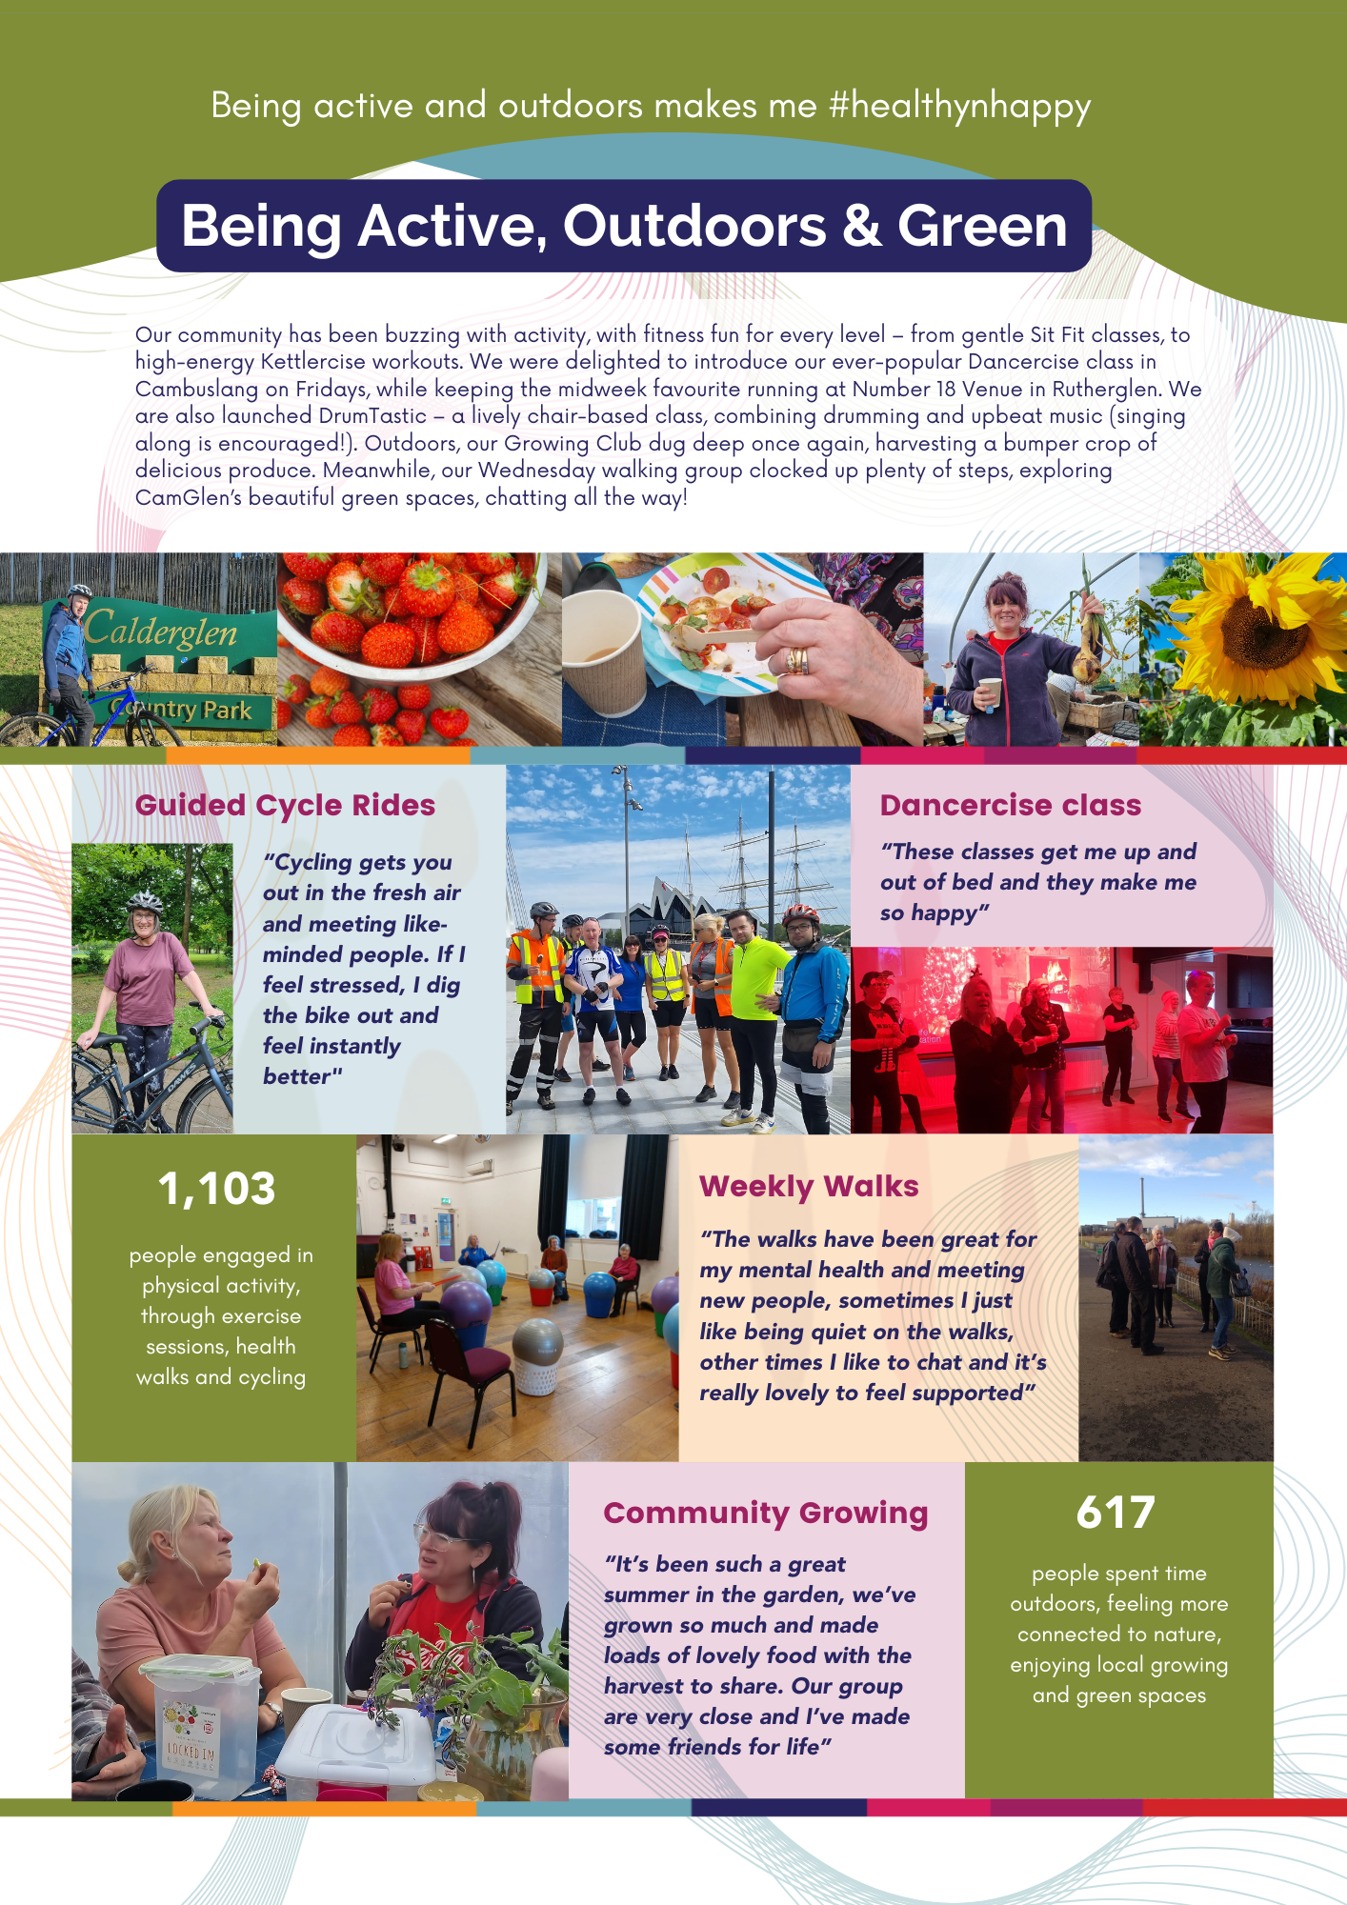
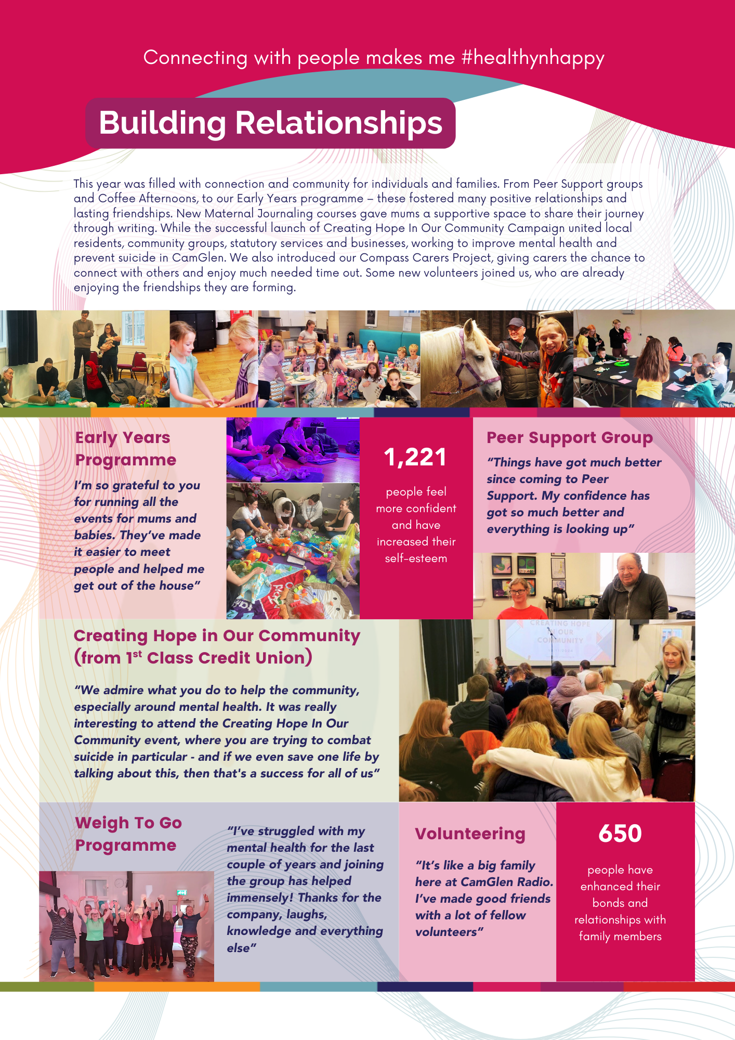
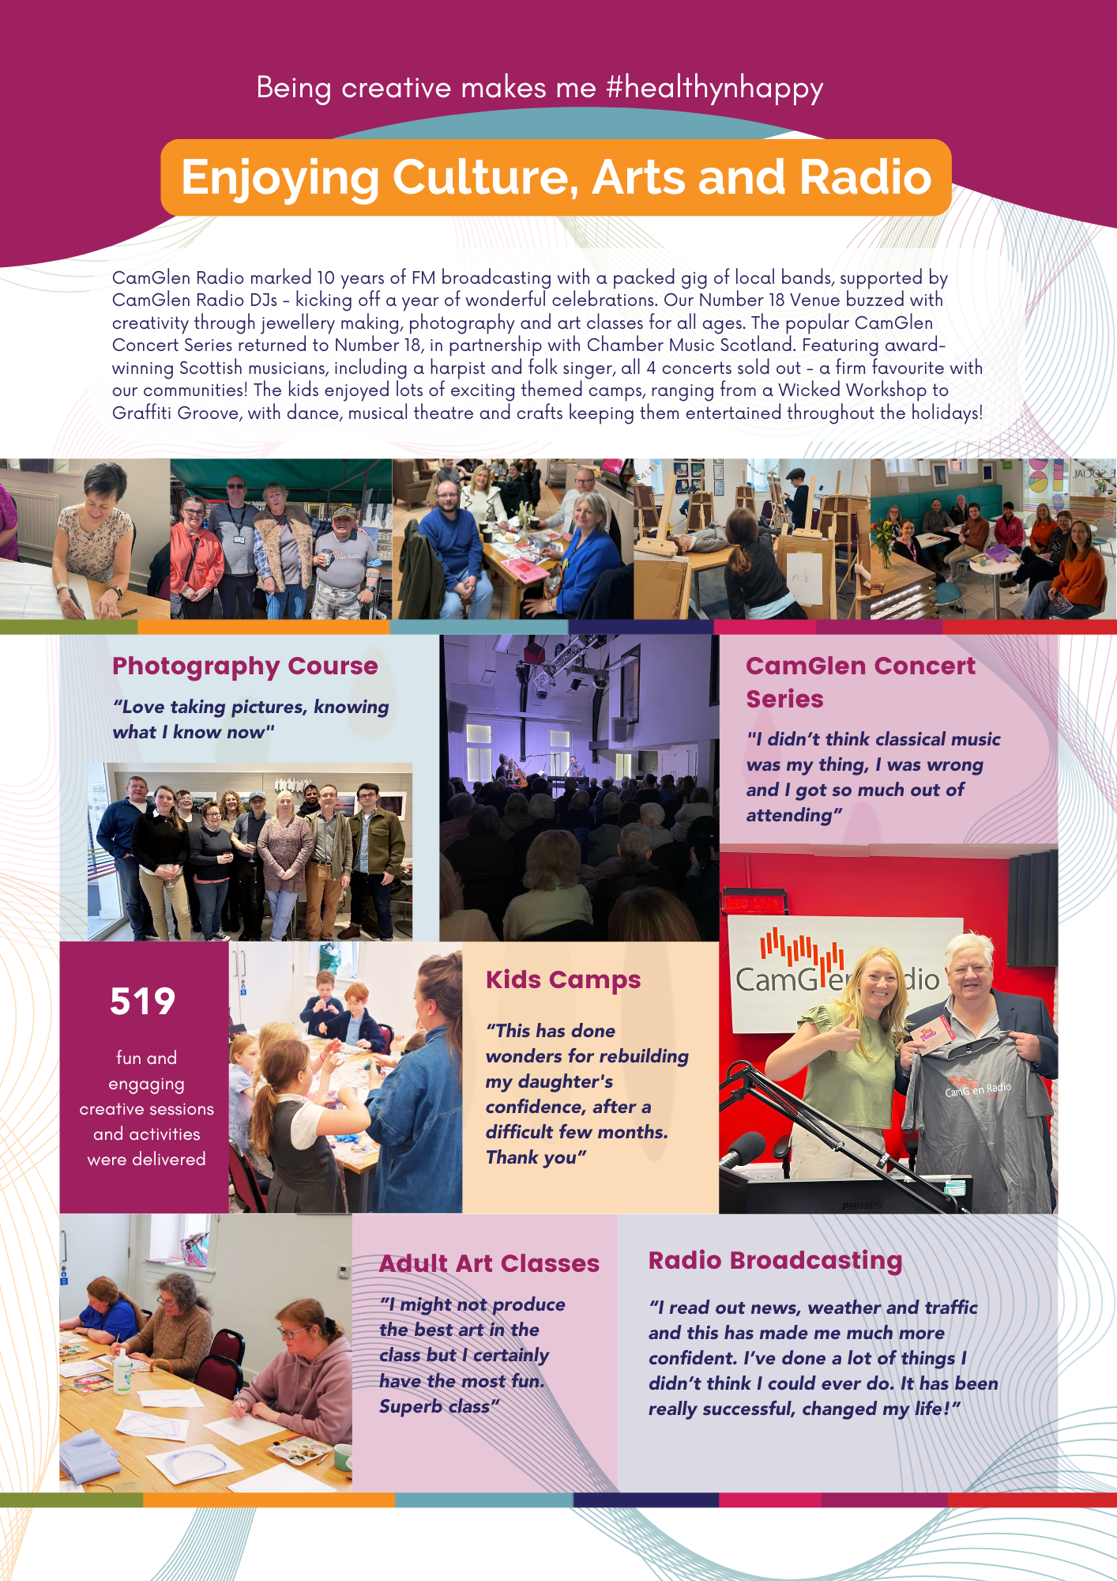
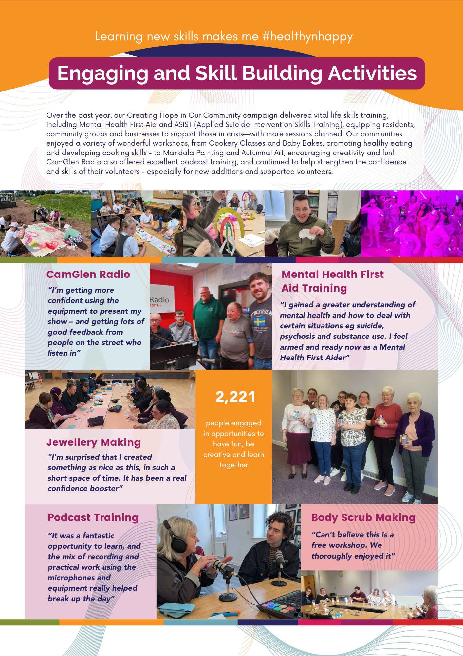
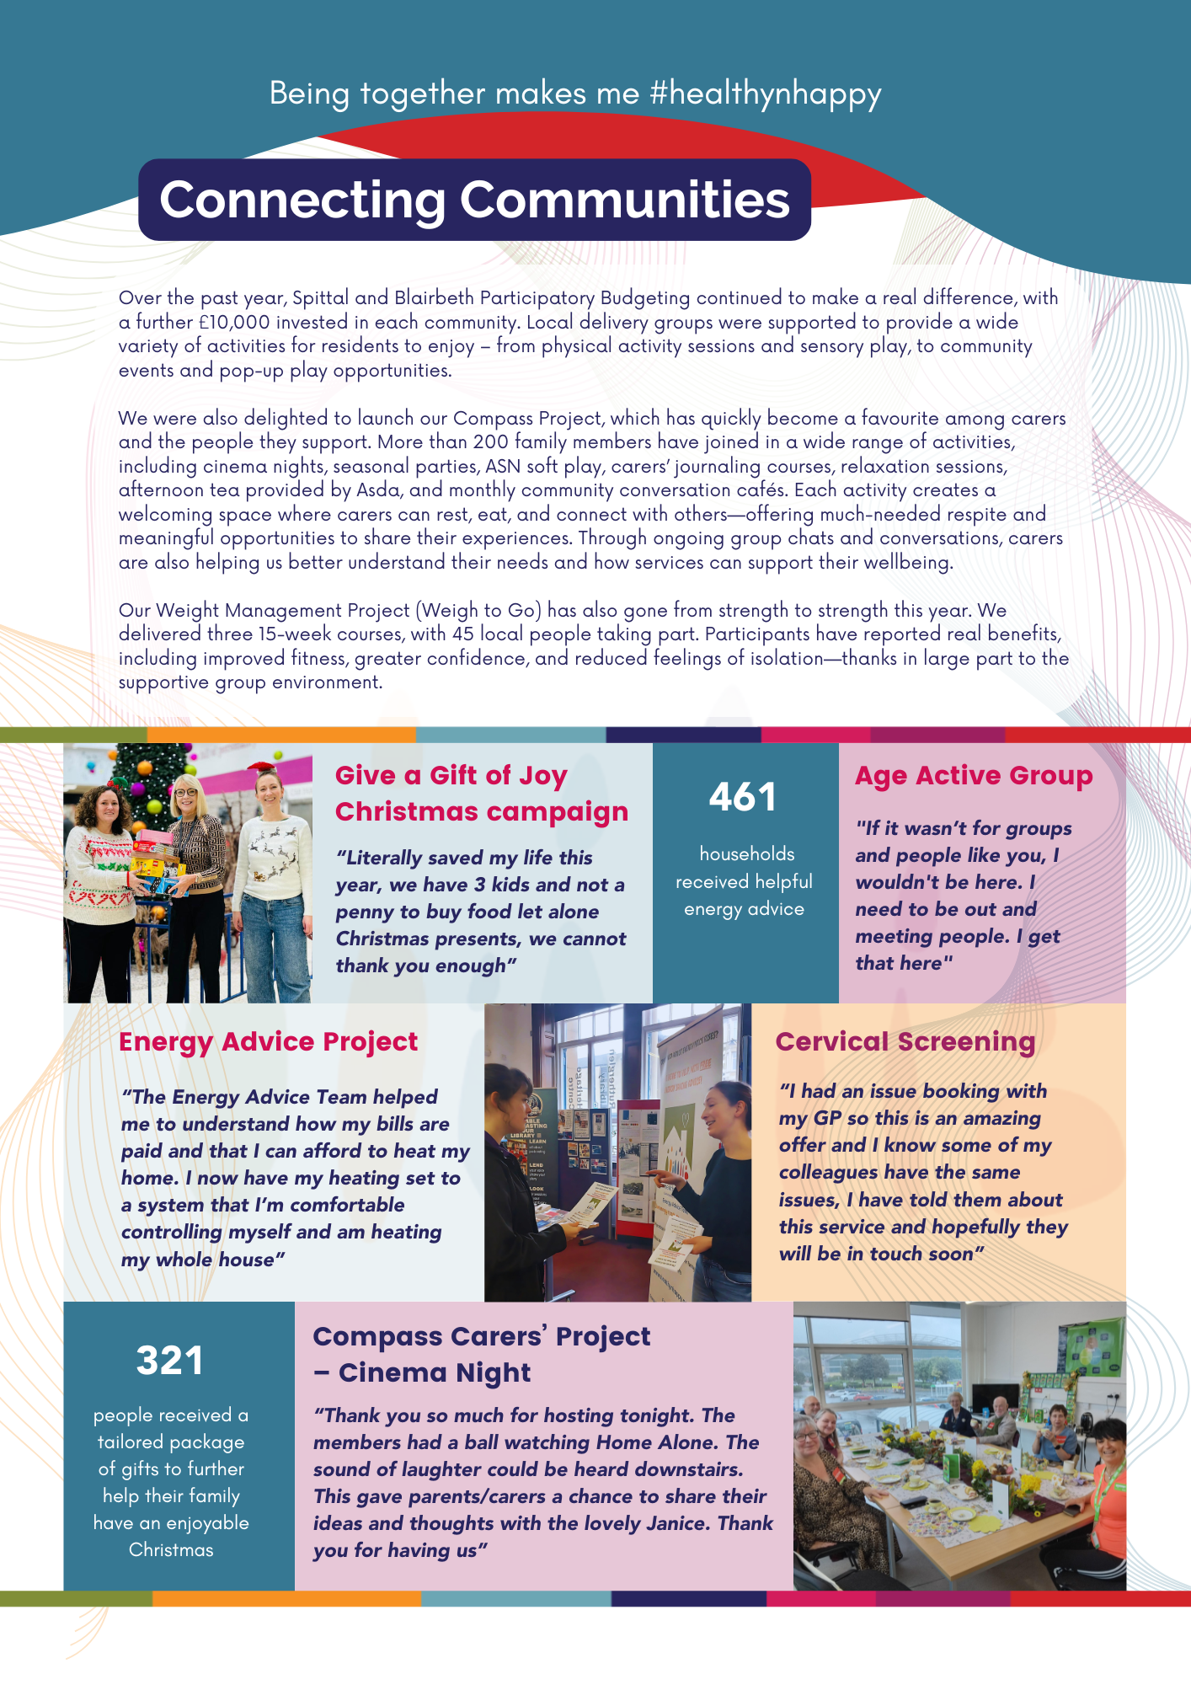

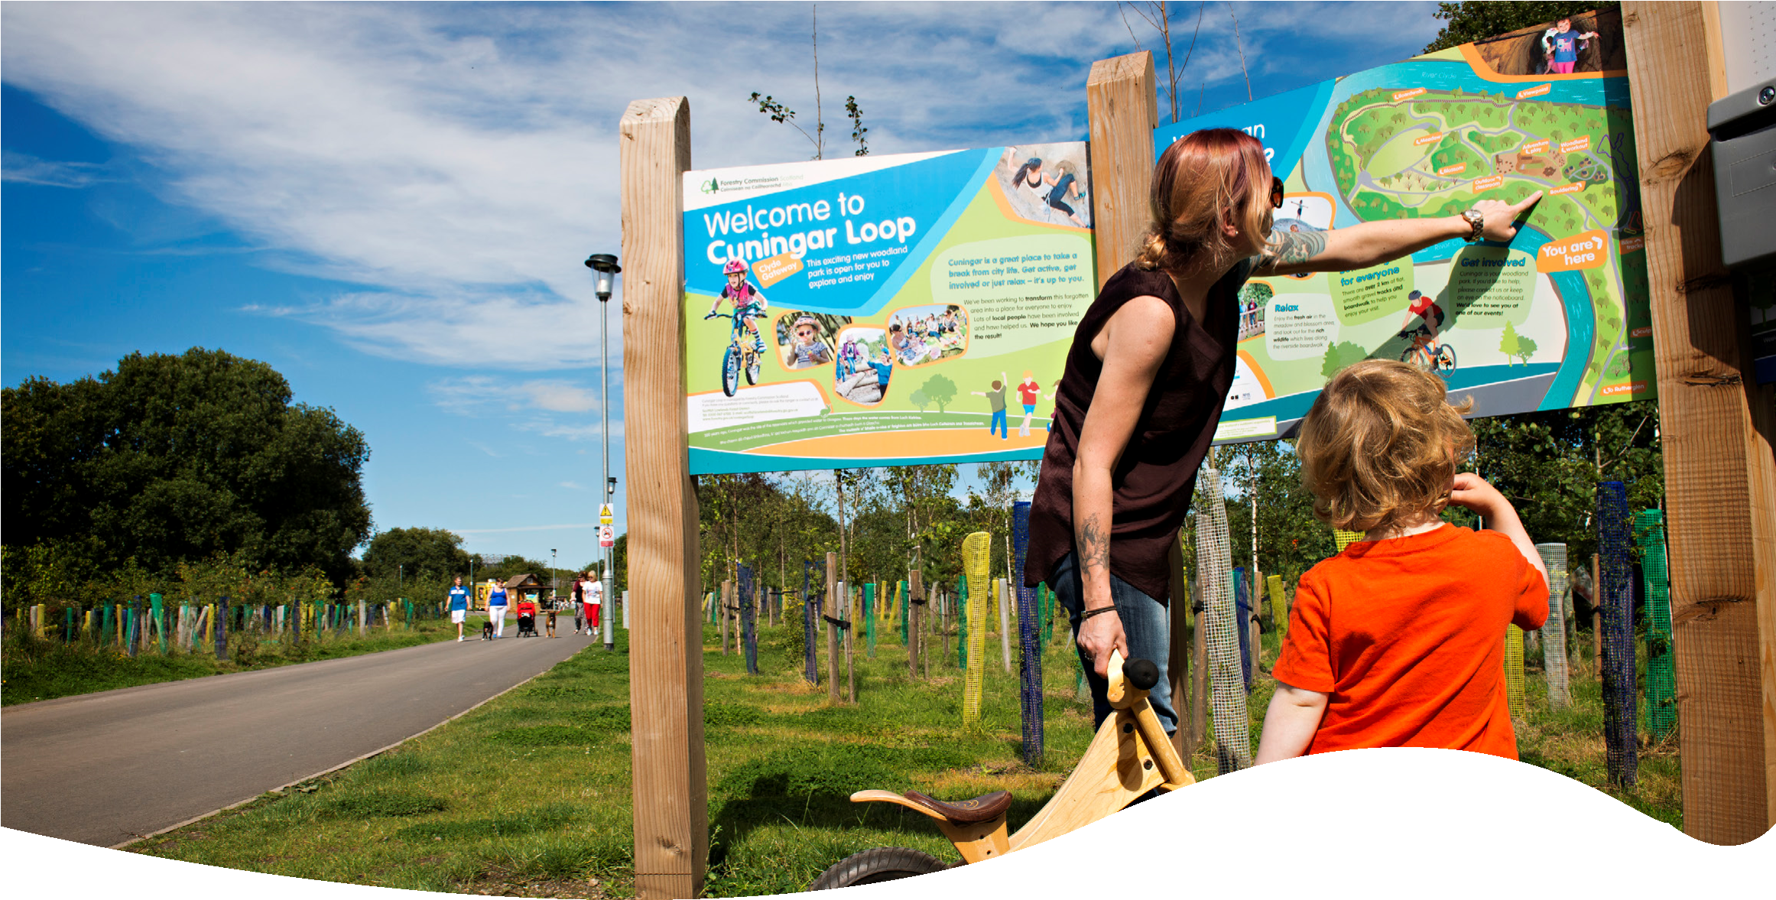
Further Information:
We encourage applicants to get in touch for an informal discussion around the role with our Executive Director. To arrange this please email angela@healthynhappy.org.uk

To apply:
Please submit with a covering letter explaining why you are suitable and what attracts you to this role, a recent CV and document detailing how you meet the relevant criteria. This should be submitted by email to angela@healthynhappy.org.uk
Strictly no agencies, not approved.

Closing date for applications:
Thursday 4 June 2026
We anticipate interviews will be held week commencing 15 June 2026
